MIACE Healthy Minds Healthy Business Public Education Campaign
Social Media Posts for Sharing
Use the social media posts below to share the #HealthyMindsHealthyBusiness public education campaign on your page! Please include the hashtag #HealthyMindsHealthyBusiness in your posts. Feel free to tag us on Facebook and LinkedIn, we’d love to see your posts!
Category 1: Mental Health Cost Calculator and Working Well Toolkit
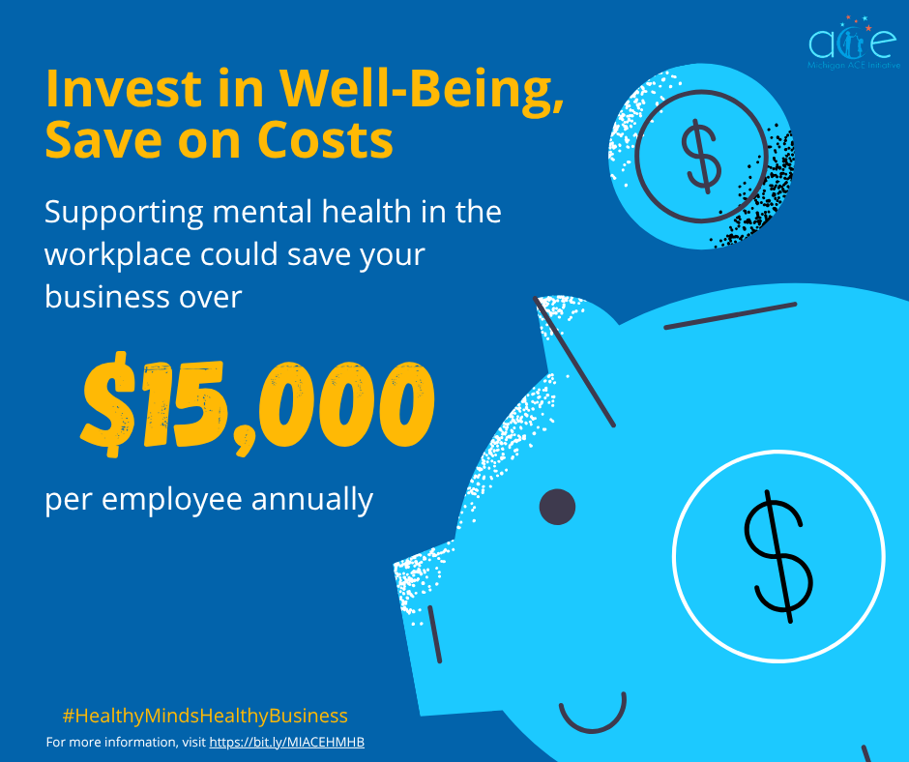
Caption: Investing in employee well-being can help reduce costs. Find out how mental health impacts your business using the Mental Health Cost Calculator: https://bit.ly/4nrGN9p.
For more information, visit https://bit.ly/MIACEHMHB.
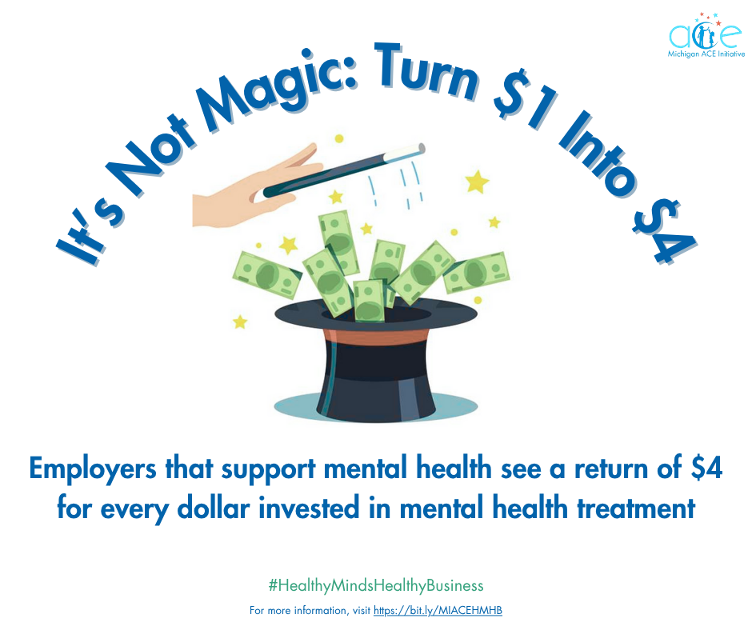
Caption: Supporting mental health treatment can be beneficial for business! Use the Mental Health Cost Calculator to calculate the impact of mental health on your business: https://bit.ly/4nrGN9p.
For more information, visit https://bit.ly/MIACEHMHB.

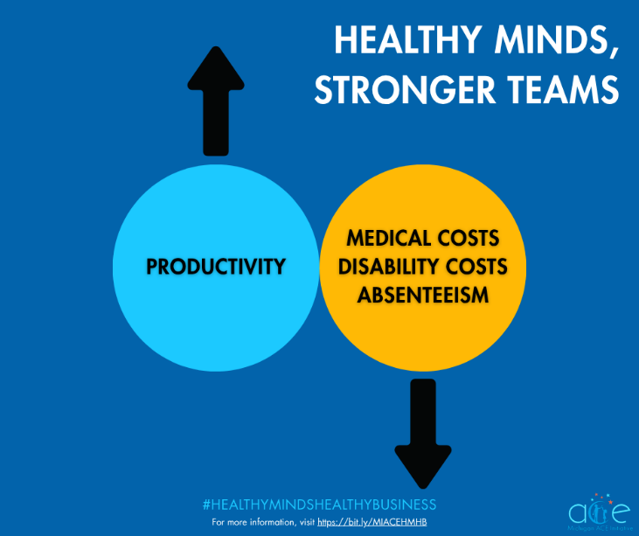
Caption: When employees receive effective treatment for mental distress, organizations achieve reduced medical costs, increased productivity, lower absenteeism, and decreased disability costs.
Learn more about how mental health affects your business using the Mental Health Cost Calculator: https://bit.ly/4nrGN9p.
For more information, visit https://bit.ly/MIACEHMHB.

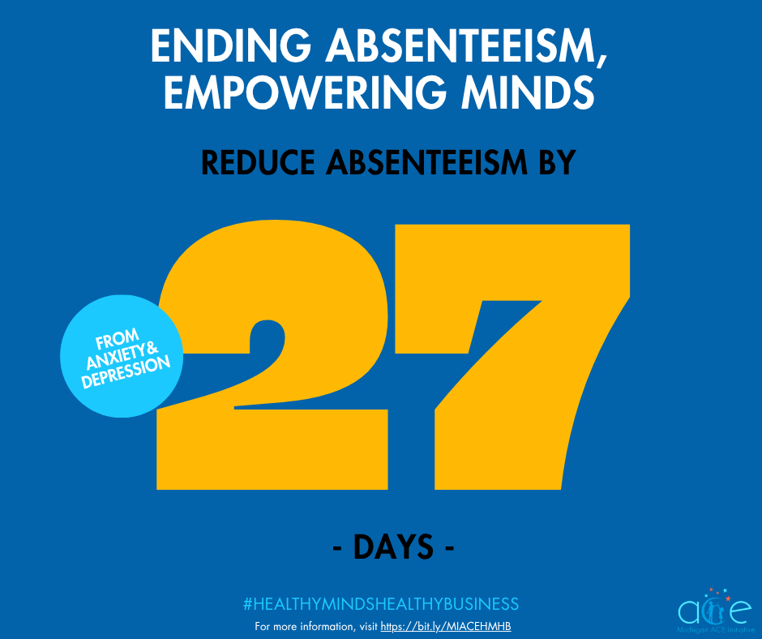
Caption: Absenteeism due to major depressive disorder and anxiety accounts for 27 or more lost workdays annually per person experiencing these conditions, and costs roughly $250 billion annually.
Find out how your business can promote mental health awareness and foster a healthy work environment by reading the Working Well Toolkit: https://bit.ly/3ZURuXX.
For more information, visit https://bit.ly/MIACEHMHB.
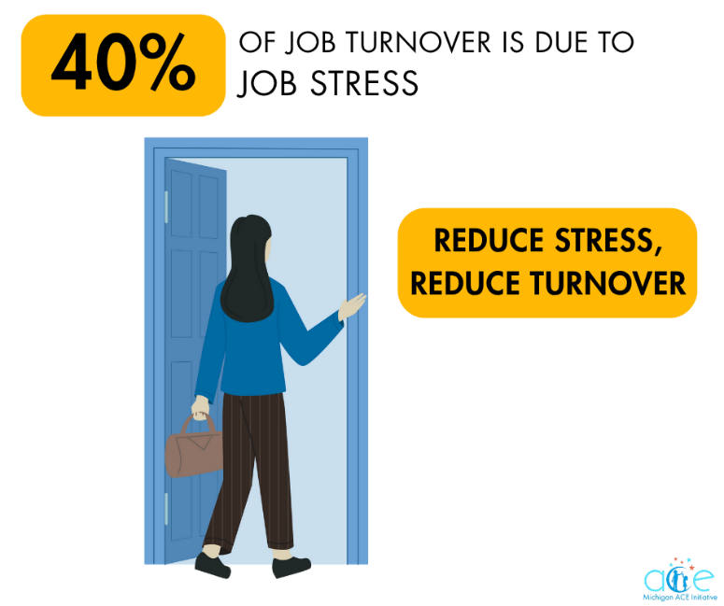
Caption: Stress alone can increase company health care costs, absenteeism, and poor performance. Promote mental health awareness and foster a healthy work environment by using the Working Well Toolkit: https://bit.ly/3ZURuXX.
For more information, visit https://bit.ly/MIACEHMHB.
Category 2: Workplace Mental Health Report
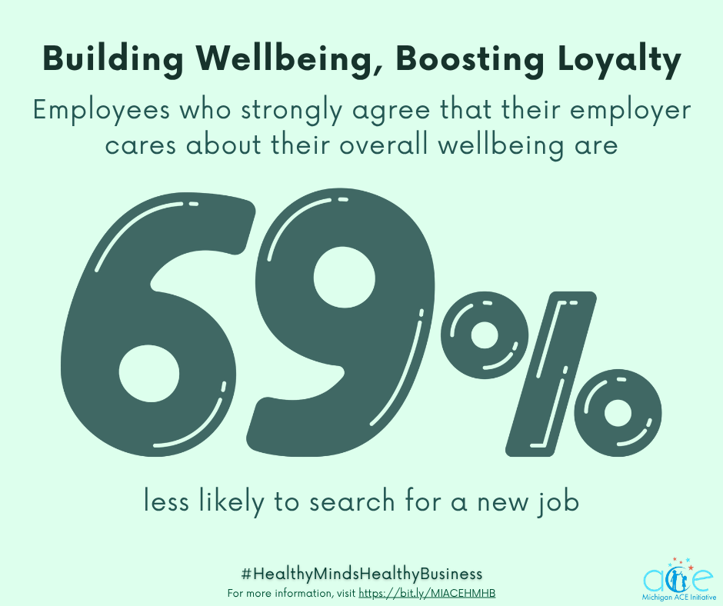
Caption: Learn more about how your business can boost loyalty among your employees by reading the Workplace Mental Health Report from the Michigan Department of Labor and Economic Opportunity: https://bit.ly/40s2ooe.
For more information, visit https://bit.ly/MIACEHMHB.
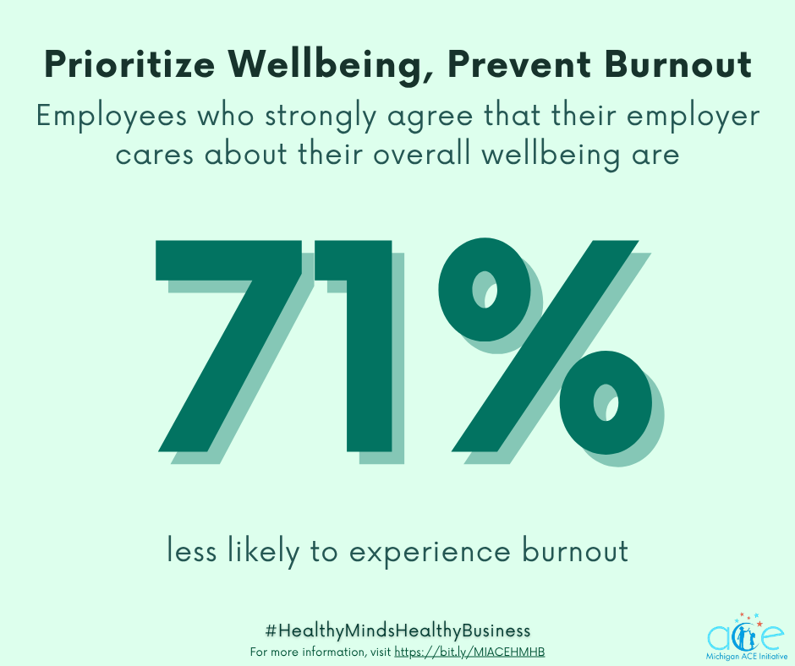
Caption: Find out how your business can prevent burnout in your employees by reading the Workplace Mental Health Report from the Michigan Department of Labor and Economic Opportunity: https://bit.ly/40s2ooe.
For more information, visit https://bit.ly/MIACEHMHB.

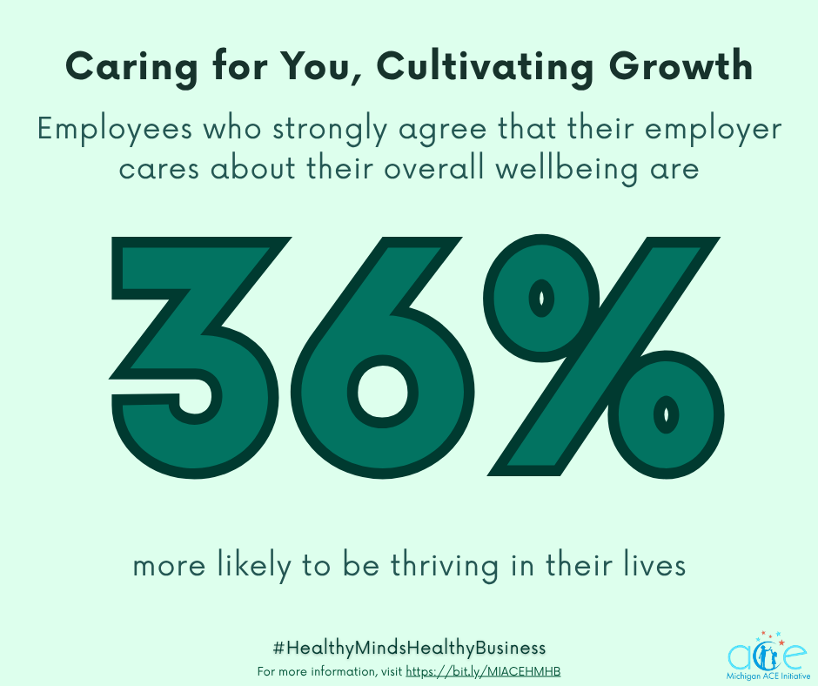
Caption: Cultivate growth in your employees with the Workplace Mental Health Report from the Michigan Department of Labor and Economic Opportunity: https://bit.ly/40s2ooe.
For more information, visit https://bit.ly/MIACEHMHB.
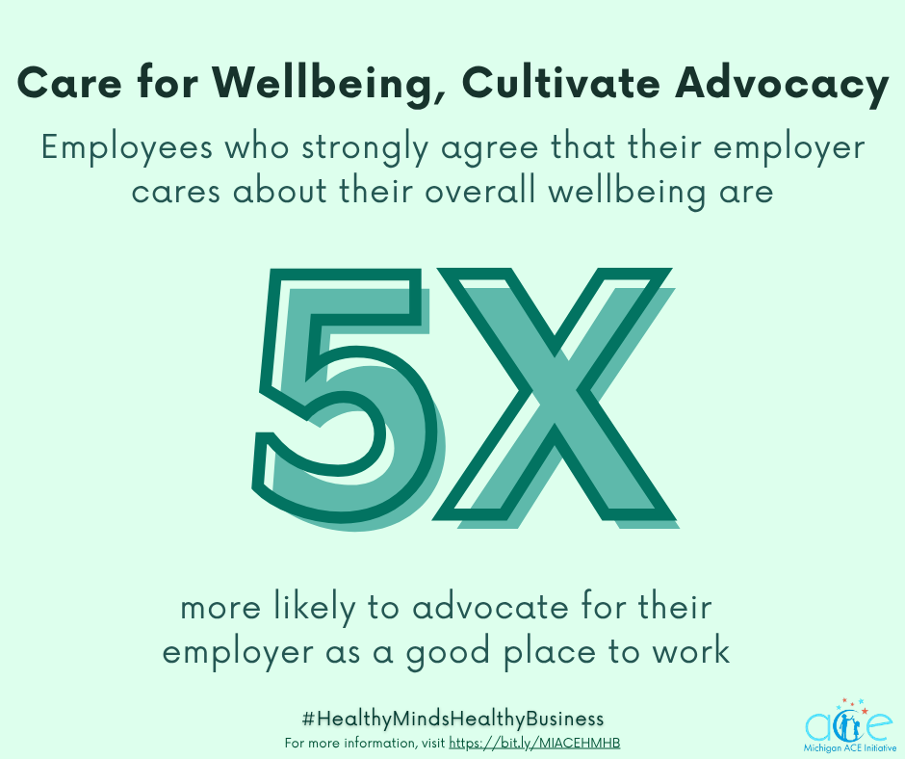
Caption: Support wellbeing in the workplace by reading the Workplace Mental Health Report from the Michigan Department of Labor and Economic Opportunity: https://bit.ly/40s2ooe.
For more information, visit https://bit.ly/MIACEHMHB.
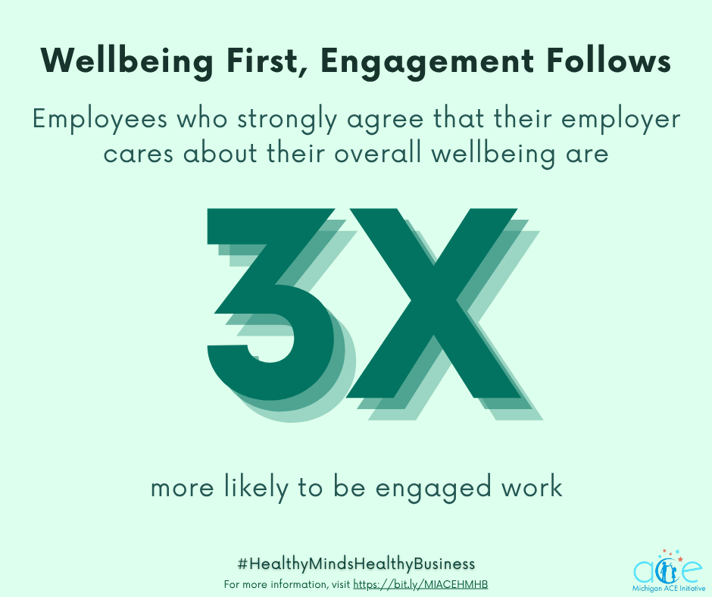
Caption: Increase engagement in your employees! To learn more, view the Workplace Mental Health Report from the Michigan Department of Labor and Economic Opportunity: https://bit.ly/40s2ooe.
For more information, visit https://bit.ly/MIACEHMHB.

Category 3: Workplace Stress Myth Busters, Working Well Toolkit, Workplace Mental Health Report
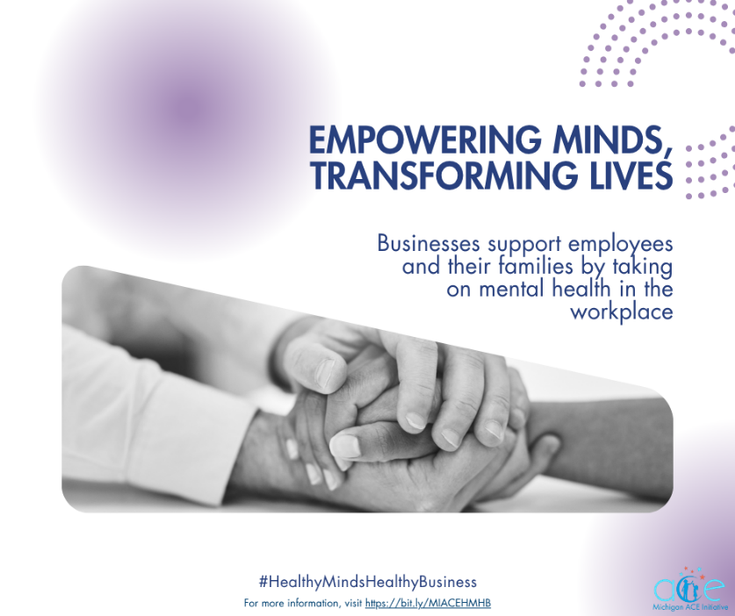
Caption: When businesses take on mental illness, they send a powerful message to employees and their families that it is okay to get help.
Find out how your business can support your employees by visiting the Working Well Toolkit: https://bit.ly/3ZURuXX.
For more information, visit https://bit.ly/MIACEHMHB.

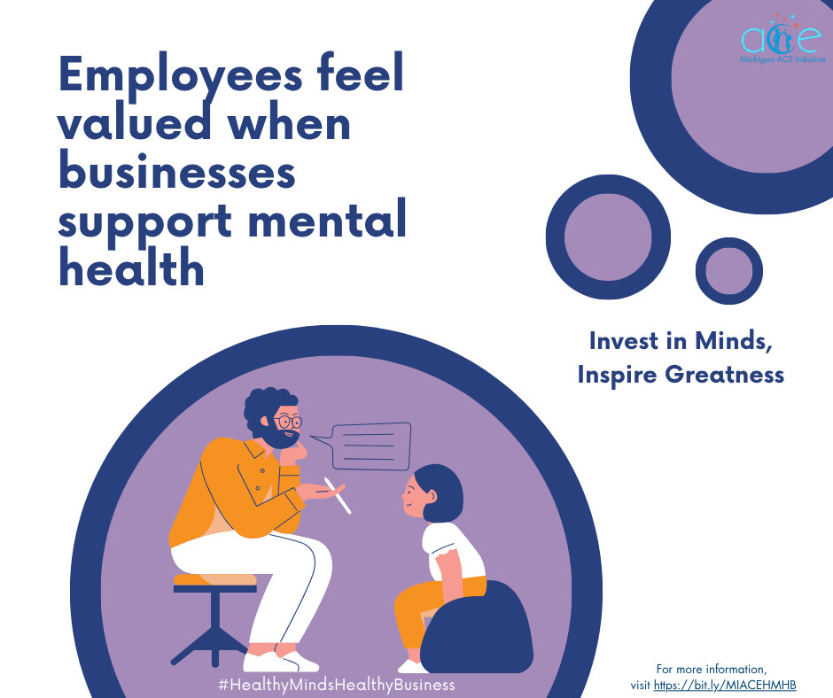
Caption: When businesses take action to support mental health, employees report feeling that their companies value and care about them as people. View the Workplace Mental Health Report from the Michigan Department of Labor and Economic Opportunity to discover more: https://bit.ly/40s2ooe.
For more information, visit https://bit.ly/MIACEHMHB.

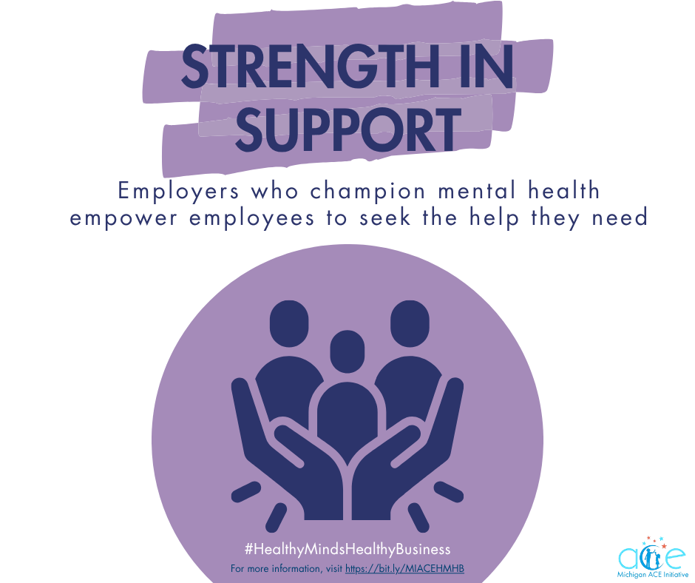
Caption: Employers wield enormous influence when fostering a supportive environment that champions mental health in the workplace, showing their employees and their families that it is a sign of strength to seek help for mental health.
Find out how your business can bust myths surrounding mental health in the workplace by reading the Workplace Stress Myth Busters by OSHA: https://bit.ly/4l6pbOG.
For more information, visit https://bit.ly/MIACEHMHB.

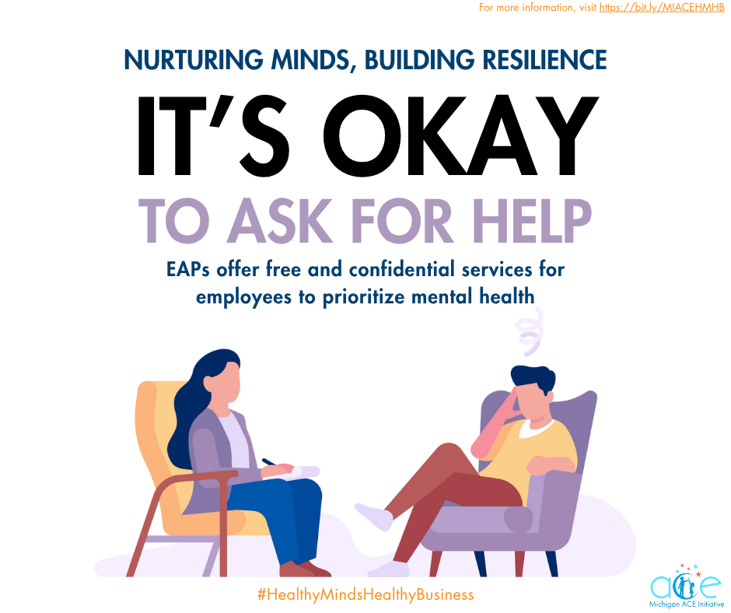
Caption: Employee Assistance Programs (EAPs) offer employees free and confidential services that can encourage employees and their families to make mental and emotional health a priority. Learn more about EAPs using the Working Well Toolkit: https://bit.ly/3ZURuXX.

For more information, visit https://bit.ly/MIACEHMHB.

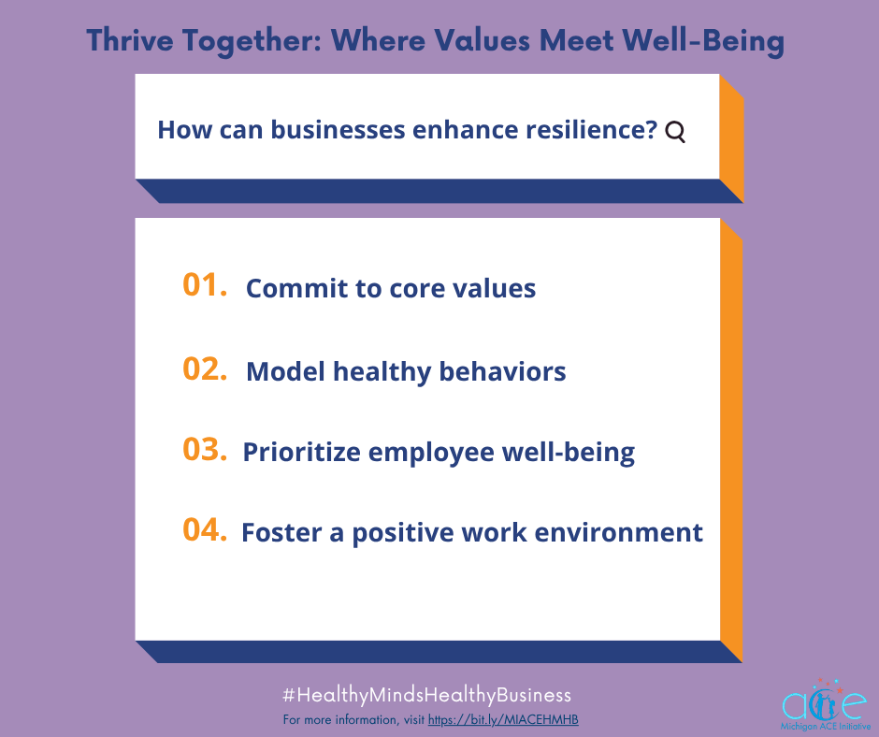
Caption: Using the Workplace Mental Health Report from the Michigan Department of Labor and Economic Opportunity, businesses that commit to their core values, model healthy behaviors and habits, and prioritize employee well-being have a profound impact on reducing stress and enhancing resilience among their employees.
This not only fosters a positive work environment but also demonstrates to employees that their organization genuinely cares about their mental health and overall well-being.
Workplace Mental Health Report: https://bit.ly/40s2ooe.
For more information, visit https://bit.ly/MIACEHMHB.

MIACE Website, Working Well Toolkit, Workplace Mental Health Report
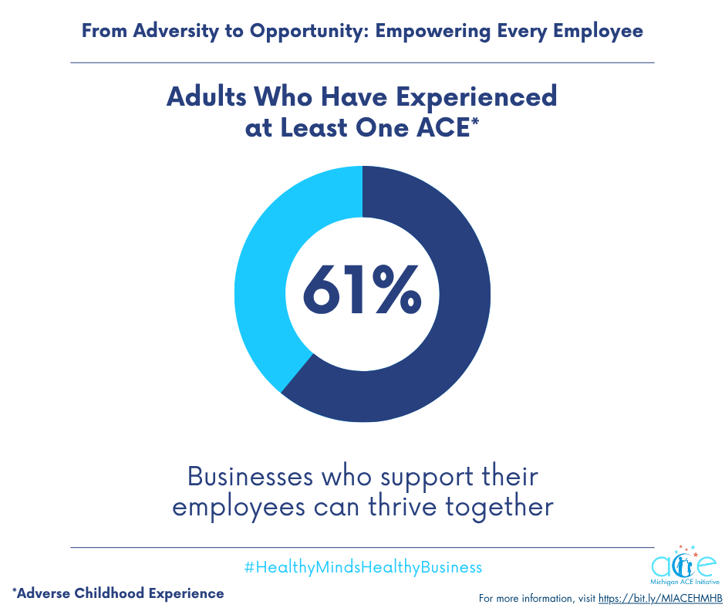
Caption: Adequate workplace supports for those who have experienced ACEs can help employees and businesses thrive together.
Visit the MIACE website to learn more about the #HealthyMindsHealthyBusiness education campaign.
For more information, visit https://bit.ly/MIACEHMHB.

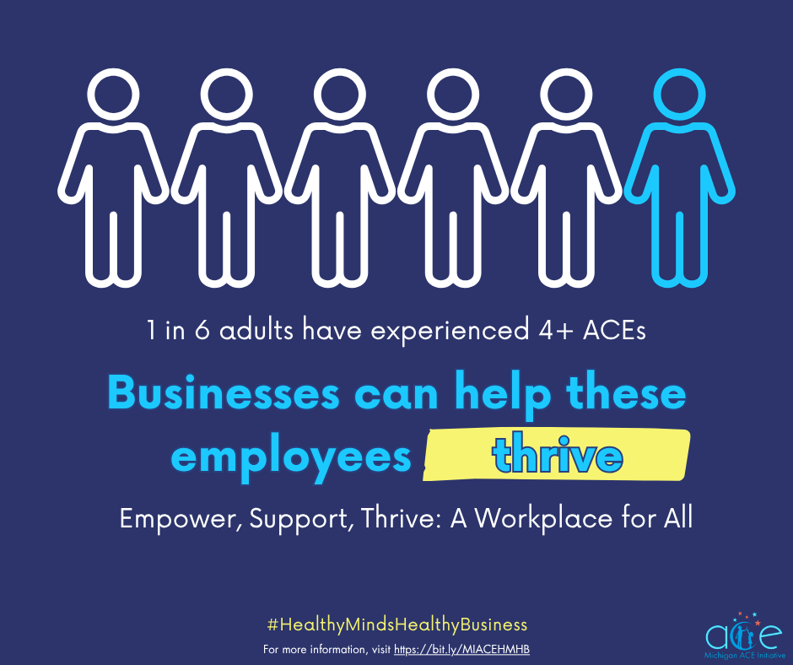
Caption: Without adequate support, Adverse Childhood Experiences (ACEs) can contribute to greater risk for job problems, absenteeism, and financial problems.
Find out more about the #HealthyMindsHealthyBusiness education campaign by visiting the MIACE website.
For more information, visit https://bit.ly/MIACEHMHB.

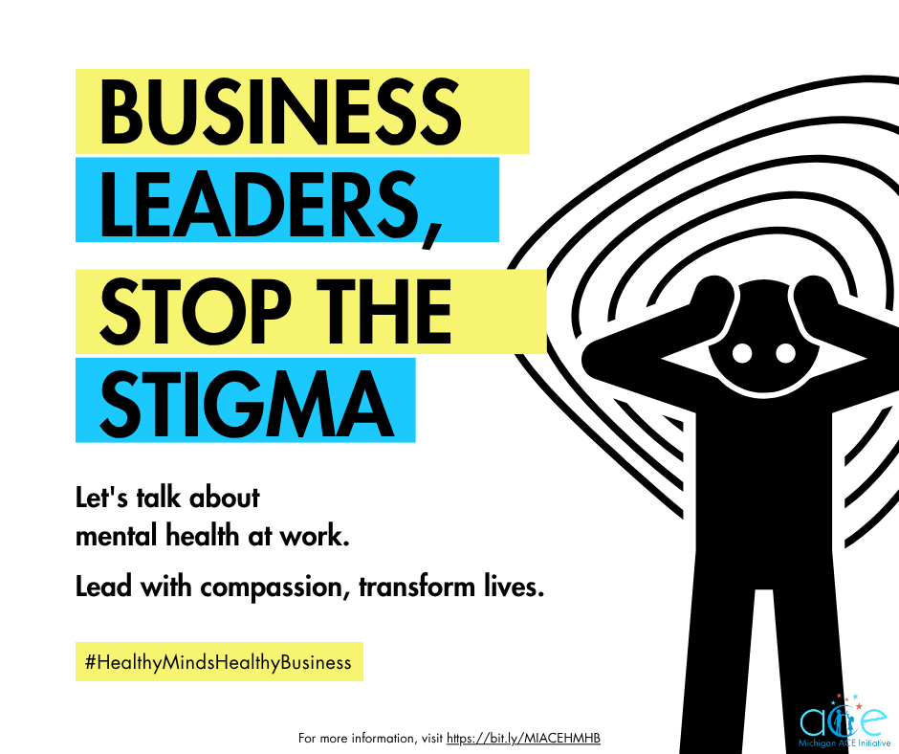
Caption: Stigma surrounding mental health can make it difficult for employees to seek the help that they need. As a business leader, you can help break the silence.
Promote mental health awareness and foster a healthy work environment by applying the Working Well Toolkit to your business: https://bit.ly/3ZURuXX.
For more information, visit https://bit.ly/MIACEHMHB.

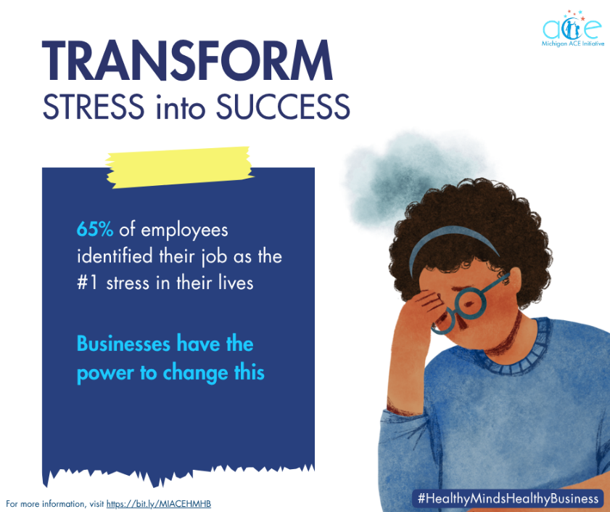
Caption: Work stress can negatively impact job quality and mental health. However, businesses have the power to help change this.
Reduce stress in the workplace by reading the Workplace Mental Health Report from the Michigan Department of Labor and Economic Opportunity: https://bit.ly/40s2ooe.
For more information, visit https://bit.ly/MIACEHMHB.

